**Topic 2**

List and describe the technology in a router and switch including interfaces.

A router operates at layer 3 of the OSI model. It does what the name suggests, it routes packets (also at layer 3) between hosts in a network and provides hosts access to the WAN (internet). The hardware the makes up a router is a CPU, USB, sometimes a heat sink (cheaper ones may not), RAM, ROM, a WAN interface, console interface (consumer one may not) and a variety of other interfaces or LAN ports. Since the prompt talks about technology involved with routers, this can be more than hardware. This could be choosing or flashing the operating system on a router (if it supports it), a popular os to run instead of the installed one is dd-wrt which comes with a ton of other configurable features. Additionally, a router can be built out of an old computer with isos such as pfsense. Pfsense is a router operating system that can be installed through a bootable drive and comes with configurable services like snort (IDS), suricata (IPS), openvpn (I found this easier in configuring site to site vpns), squid (proxy) and almost to many features to list. Other technology that is involved with routers are routing tables, router solicitations and router advertisements. The routing table is controlled by the routers hardware and software and used by routers to determine the route or interface to send packets through. As an example, if one machine in one subnet wanted to communicate to a machine in another subnet using the routing table as an example (vlans communicate two subnets), host A in example subnet 192.168.1.1/25 would send the request to the default gateway, which would check its routing tables to see which interface to use to reach Host B in 192.168.1.128/25 (fa 0/1 -> 192.168.1.128/25). This database is stored in the routers RAM and contains a list of all networks that it knows routes for. Router solicitations are used by systems to discover routers. Router Advertisements are the response sent back to the systems, informing them that the ip allows routing (is a router). DHCP, NAT and DNS are also common protocols used by routers for addressing and to distinguish ip addresses to domains. NAT is responsible for assigning the public ip (a public ip if multiple) to a private system or group of systems, allowing them to access the WAN (internet).

A switch is very similar in terms of its inner-hardware. Network switches can operate at layer 3 and use routing tables to determine where to route packets. Traditional switches operate at layer 2 and do not use routing tables rather MAC tables and ARP tables. MAC tables are a database the associates a destinations MAC address to a port on the switch (fa 0/1 -> ff-ff-ff-ff-ff-ff). This helps it to distinguish where to forward frames in the LAN. The ARP table is a database of hardware addresses and their LAN ip addresses. ARP is a layer 2 protocol and frames are also found at layer 2. Switches can also be either managed or unmanaged. An unmanaged switch allows for just plugging and working, there isn't any need to setup or tweak configurations. Managed switches allow for setting up and editing configurations in the switch for better control, typically, through a console interface. Other differences between a switch and router are that a switch will generally have more LAN interfaces for hosts to connect to. Switches also help eliminate or reduce collisions in the network by interpreting bits in received frames allowing them to distinguish the only needed port to send frames through instead of all ports. Additionally, switches will buffer frames, if numerous frames are being sent out the same port, the switch will send the frames individually to avoid collisions.

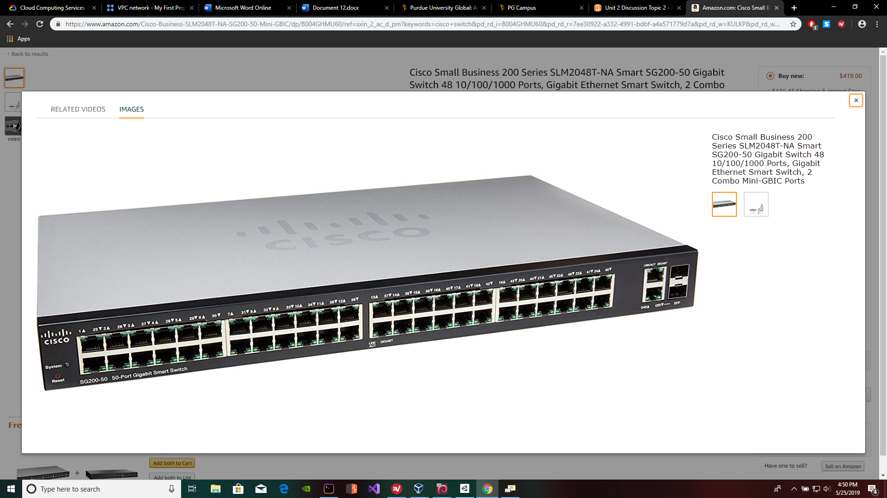

<https://www.amazon.com/Cisco-Business-SLM2048T-NA-SG200-50-Mini-GBIC/dp/B004GHMU60/ref=sxin_2_ac_d_pm?keywords=cisco+switch&pd_rd_i=B004GHMU60&pd_rd_r=7ee30922-a332-4991-bdbf-a4a571779d7a&pd_rd_w=KULKP&pd_rd_wg=aRjOO&pf_rd_p=5cc8abfe-8f78-4f34-b19f-d09d6ea0dca4&pf_rd_r=MQXG1EY9RSYZ2X2DGQXH&qid=1558817403&s=gateway>

Example of switch interfaces

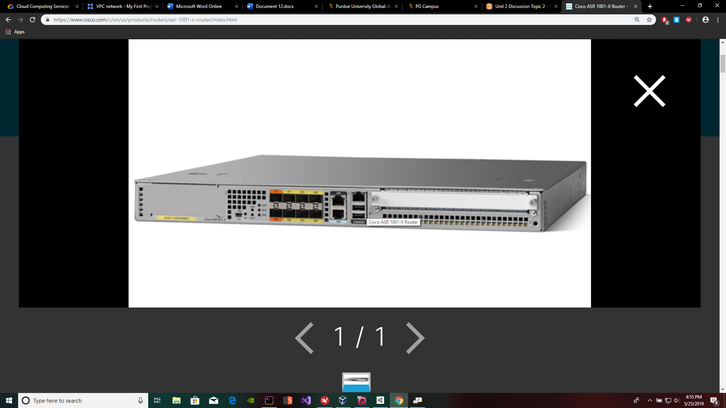

<https://www.cisco.com/c/en/us/products/routers/asr-1001-x-router/index.html>

Cisco router interfaces example

<https://www.cisco.com/c/en/us/solutions/small-business/resource-center/networking/network-switch-how.html>

<https://www.cisco.com/assets/sol/sb/RV320_Emulators/RV320_Emulator_v1.0.1.01/help/DHCP7.html>

<http://www.pearsonitcertification.com/articles/article.aspx?p=2339639&seqNum=3>

<https://learningnetwork.cisco.com/thread/6816>

<http://www.ciscopress.com/articles/article.asp?p=1276662&seqNum=7>